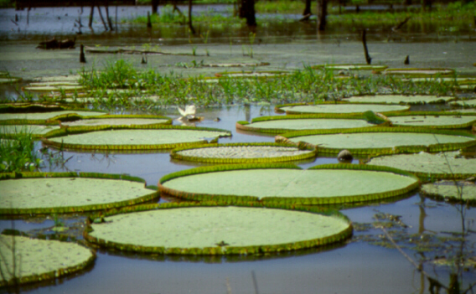
Course organized by Charles University, Faculty of Science
V případě zájmu kontaktujte co nejdříve, nejpozději však do 13.10. 2004, J. Albrechtovou – email: albrecht@natur.cuni.cz.
In collaboration with the Institute of Landscape Ecology of Academy of Sciences of the Czech Republic, South-Bohemian University in České Budějovice
and Administration of the Šumava National Park

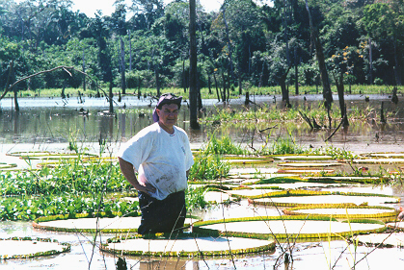
“Aquatic plants: environmental adaptations, biodiversity and phytogeographic distribution”

Lecturer: Dr. Garrett E. Crow
University of New Hampshire,
Department of Plant Biology, Durham, U.S.
e-mail: garrett.crow@unh.edu

October 14 (Charles University) and 17-20 (Lužnice by Třeboň, Šumava NP), 2004

Main Course Organizer: Dr. Jana Albrechtová
Charles University (CU), Department of Plant Physiology
e-mail: albrecht@natur.cuni.cz
The course is organized as a part of the doctoral project Local adaptations in plant populations.
Course Co-Organizers: Dr. Jan Pokorný
Institute of Landscape Ecology (ILE) of Academy of Sciences of the Czech Republic
e-mail: pokorny@esnet.cz

Dr. Tomáš Kučera
Institute of Landscape Ecology of Academy of Sciences of the Czech Republic
e-mail: kucera@uek.cas.cz

Excursion Organizers: Dr. Tomáš Kučera, Dr. Jan Pokorný (18 and 19 October)
Dr. Ivana Bufková (20 October)
Administration of the Šumava National Park, Protected Landscape and Biosphere Reserve
e-mail: ivana.bufkova@npsumava.cz

Course description: The course will consists from lectures given by Dr. Crow and field excursions lead by Dr. Pokorný, Dr. Kučera and Dr. Bufková. It will focus on aquatic plants and their adaptations. Topics will incude: Phylogenetic affinities, diversity, and morphological and anatomical adaptations to the aquatic environment, adaptations for sexual and vegetative reproduction, invasive aquatics, phytogeographical affinities of peatland plants in relation to Pleistocene glaciation, and is diversity really higher in temperate regions than in the tropics.

Charles University in Prague, Faculty of Science

October 14, 2004

Thursday
Charles University in Prague, Fac. Sci., Dept. of Plant Physiology, Viničná 5, Prague 2, 2nd floor, Seminar Room

- 12:30 – 13:30 Lecture: Aquatic plants and phylogenetic affinities
- 13:45 – 15:45 Lecture: Adaptations for Reproduction: Sexual reproduction
- 16:00 – 17:00 Lecture: Adaptations for Reproduction: Vegetative reproduction

South Bohemia
Accomodation 17-20 October, 2004, arranged in the Experimental Station (ES) Lužnice by Třeboň

October 17, 2004

Sunday
Institute of Landscape Ecology of Academy of Sciences of the Czech Republic, Dukelská 145, Třeboň

- 15:00 – 16:00 Lecture: Adaptive Features of Aquatic Plants: Adaptation to the Aquatic Environment Part 1
- 16:15 – 17:15 Lecture: Adaptation to the Aquatic Environment Part 2
- 17:30 – 18:30 Lecture: Comparison of Diversity in Created Wetlands in southeastern New Hampshire, USA.
- Reading Assignments (for discussion on Tuesday, 19 Oct):
Philbrick, C. T. and D. H. Les. 1996. Evolution of aquatic angiosperm reproductive systems. Bioscience 46: 813-826.
Stuckey, R. L. 1993. Phytogeographical outline of aquatic and wetland angiosperms in continental eastern North America. Aquatic Botany 44: 259-301.
Crow, G. E. 1969. A phytogeographical analysis of a southern Michigan bog. Michigan Bot. 8: 51-60.
Crow, G. E. 1993. Species diversity in aquatic angiosperms: latitudinal patterns. Aquat. Bot. 44: 229-258. [Special Issue comprising papers from 1991 AIBS symposium: "Evolution of Aquatic Angiosperms"]

October 18, 2004
Monday
ES Lužnice by Třeboň
  - 8:30 – 9:30 Lecture: Pleistocene glaciation in North America and post-Pleistocene migrations.
  - 9:45 – 10:45 Lecture: Case study: Peatlands and phytogeographical affinities of a southern Michigan bog.
  - 11:00 – 14:30 Reading Assignments: (for discussion on Tuesday, 19 Oct): continuing
  - 14:30 – 18:30 Field Excursion to the Fish Ponds
lead by Dr. Pokorný and Dr. Kučera
Topic: Nutrient cycling and regime in fish pond water ecosystems
  - evening Reading Assignment: (for Field Excursion on Tuesday, 19 Oct):
Kučerová, A. 2001. Čtyři roční období v třeboňských blatových borech [Four Seasons in the Třeboň Peat Bogs with Pinus rotundata]. Živa, 6: 251-254.

October 19, 2004
Tuesday
ES Lužnice by Třeboň
  - 8:30 – 13:00 Field Excursion to the Červené Blato Peatbog and Stará řeka (polder wetland)
lead by Dr. Kučerová
Topic: hydrology of the Červené Blato peatbog with central European endemite Pinus rotundata
- 13:00 – 14:00 Lunch
- 14:00 – 16:00 Field Excursion to the Stará řeka (polder wetland)
lead by Dr. Kučera
Topic:
- 18:00 – 19:30 Discussion on Reading Assignments
- 20:00 – 21:00 Lecture: Tropical Aquatic Plant Diversity (Costa Rica, Amazonia)

October 20, 2004
Wednesday
Šumava NP

  - 7:00 – 10:00 Transportation to the cross road by the village Pěkná, Šumava NP, meeting with Dr. Bufková at 10:00
  - 7:00 – 10:00 Transportation to Šumava NP
  - 8:30 – 17:00 Field Excursion to peatlands of the Sumava Mts. (the Upper Vltava River, central upland area-Tetřevská slať peatbog)
lead by Dr. Bufková
Topics: 1) Relationships between vegetation and environment within the montane floodplain of the Upper Vltava River
2) Vegetation of raised bogs and transitional mires in the central plateau of the Sumava Mts.

  - evening End of course - Transportation home

Instructor: Dr. Garrett E. Crow is a taxonomist and phytogeographer with a special interest in biodiversity in aquatic vascular plants. He is Professor of Botany and Director of the Herbarium, Department of Plant Biology, University of New Hampshire, and currently serves as department Chairman. He has had extensive experience in temperate and tropical aquatic ecosystems. He holds a M. S. and .Ph.D. from Michigan State University. He is co-author of the definitive 2-volume taxonomic work: Aquatic and Wetland Plants of Northeastern North America, University of Wisconsin Press, Madison, WI, USA (2000), and author of Plantas acuáticas del Parque Nacional Palo Verde y Valle Tempisque, Costa Rica / Aquatic plants of Palo Verde National Park and the Tempisque Valley, Costa Rica. (A bilingual field guide). Instituto Nacional Biodiversidad (INBio), Santo Domingo de Heredia, Costa Rica (2002).

